38 - Clash – Should I Stay
Orginal key: D Us: Ab

Plan
Intro: 4 bars of riff
Verse 1, 2
Verse 3 ska time
Verse 4
Verse 5 instrumental
Verse 6 ska time
Verse 7 ska time, leave out bars 3 & 4

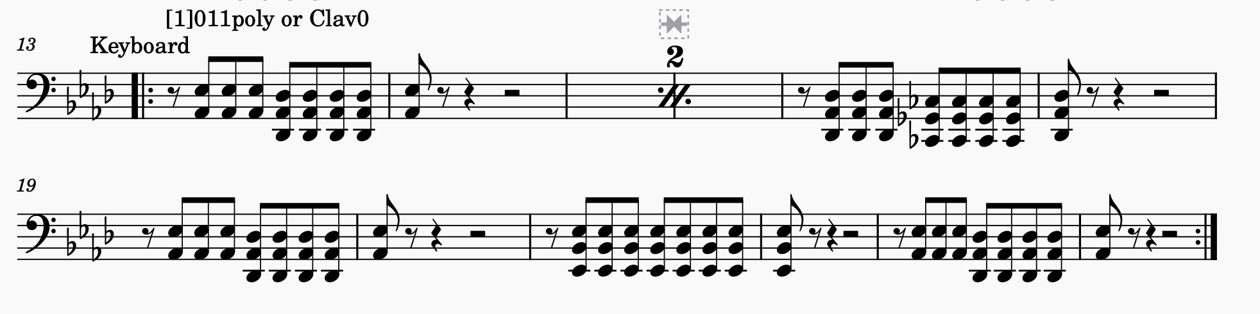
Verse 3  This indecision's bugging me (Esta indecisión me molesta)  If you don't want me, set me free (Si no me quieres, librarme)  Exactly whom I'm supposed to be (Dígame que tengo ser)  Don't you know which clothes even fit me? (Sabes que ropa me "quedrá"?)  Come on and let me know (Me tienes que decir)  Should I cool it, or should I blow? (Me debo ir o quedarme?) | Verse 6 & 7  Should I stay, or should I go now? (Yo me enfrío o lo soplo)  If I go, there will be trouble (Si me voy va a haber peligro)  And if I stay, it will be double (Si me quedo sera el doble)  So ya gotta let me know (Me tienes que decir)  Should I cool it, or should I blow? (Tengo frío por los ojos)

